**Tugas 1 - Distance Metric**

Nama : Rizqi Rohmatul Huda

Kelas : 2G – TI

No.Absen : 26

NIM : 2141720264

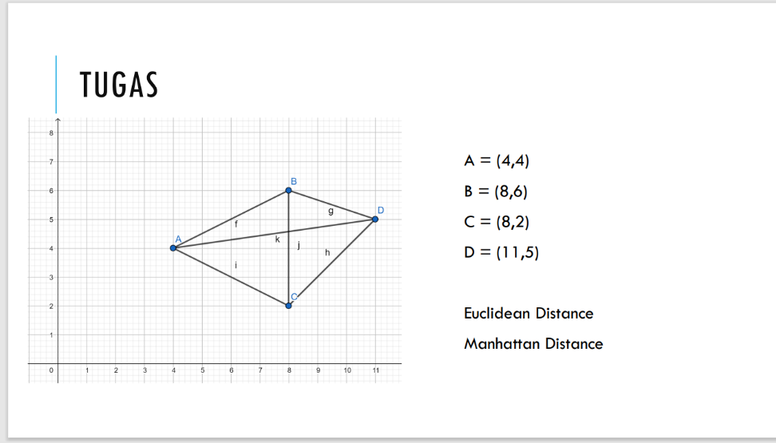

A. Euclidien Distance

Koordinat titik :

* A = (4, 4)
* B = (8, 6)
* C = (8, 2)
* D = (11, 5)

Distance :

1. f (A, B)
2. g (B, D)
3. h (D, C)
4. i (A, C)
5. j (B, C)
6. k(A, D)

Rumus :

d (x , y) = i – yi )2

Jawaban

1. f (A, B)

A = (4, 4)

B = (8, 6)

d = $\sqrt{{(4-8)}^{2}+{(4-6)}^{2}}$

d = $\sqrt{{(-4)}^{2}+{(-2)}^{2}}$

d = $\sqrt{16+4}$

d = $\sqrt{20}$

d = 2 $\sqrt{5}$

1. g (B, D)

B = (8, 6)

D = (11, 5)

d = $\sqrt{{(8-11)}^{2}+{(6-5)}^{2}}$

d = $\sqrt{{(-3)}^{2}+{(1)}^{2}}$

d = $\sqrt{9+1}$

d = $\sqrt{10}$

1. h (D, C)

C = (8, 2)

D = (11, 5)

d = $\sqrt{{(8-11)}^{2}+{(2-5)}^{2}}$

d = $\sqrt{{(-3)}^{2}+{(-3)}^{2}}$

d = $\sqrt{9+9}$

d = $\sqrt{18}$

d = $3\sqrt{2}$

1. i (A, C)

A = (4, 4)

C = (8, 2)

d = $\sqrt{{(4-8)}^{2}+{(4-2)}^{2}}$

d = $\sqrt{{(-4)}^{2}+{(2)}^{2}}$

d = $\sqrt{16+4}$

d = $\sqrt{20}$

d = 2 $\sqrt{5}$

1. j (B, C)

B = (8, 6)

C = (8, 2)

d = $\sqrt{{(8-8)}^{2}+{(6-2)}^{2}}$

d = $\sqrt{{(0)}^{2}+{(4)}^{2}}$

d = $\sqrt{16}$

d = $4$

1. k (A, D)

A = (4, 4)

D = (11, 5)

d = $\sqrt{{(4-11)}^{2}+{(4-5)}^{2}}$

d = $\sqrt{{(-7)}^{2}+{(-1)}^{2}}$

d = $\sqrt{49+1}$

d = $\sqrt{50}$

d = $5\sqrt{2}$

B. Manhattan Distance

Koordinat titik :

* A = (4, 4)
* B = (8, 6)
* C = (8, 2)
* D = (11, 5)

Distance :

1. f (A, B)
2. g (B, D)
3. h (D, C)
4. i (A, C)
5. j (B, C)
6. k(A, D)

Rumus :

d|

1. f (A, B)

A = (4, 4)

B = (8, 6)

d = |4 – 8| + |4 – 6|

d = |-4| + |-2|

d = 4 + 2

d = 6

1. g (B, D)

B = (8, 6)

D = (11, 5)

d = |8 – 11| + |6 – 5|

d = |-3| + |-1|

d = 3 + 1

d = 4

1. h (C, D)

C = (8, 2)

D = (11, 5)

d = |8 – 11| + |2 – 5|

d = |-3| + |-3|

d = 3 + 3

d = 6

1. i (A, C)

A = (4, 4)

C = (8, 2)

d = |4 – 8| + |4 – 2|

d = |-4| + |2|

d = 4 + 2

d = 6

1. j (B, C)

B = (8, 6)

C = (8, 2)

d = |8 – 8| + |6 – 2|

d = |4|

d = 4

1. k(A, D)

A = (4, 4)

D = (11, 5)

d = |4 – 11| + |4 – 5|

d = |-7| + |-1|

d = 7 + 1

d = 8